Structure of the “main.cpp” file.

#include <iostream>: It is a library. Input/output stream >= It is going to help us access the console, read things from the user and also from the keyboard and display.

Int main(){}: Where is your program starting?

One-line comments are written using “//” two forward slashes. Using comments in your code is a good habit.

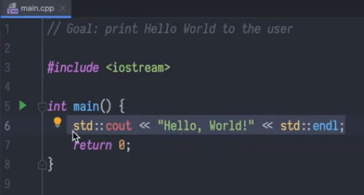

“cout” stands for console Out. (std::cout << “hello world”) means to print “Hello World on the console while (<< std::end;) indicates an end-line.

The return 0; will appear at the bottom of your main function to help it terminate.

End all lines with a semi-colon.

When writing a string to be printed on the console, always use the std(standard)::cout(ConsoleOUT) then “<<”